


The Casualty Actuarial Society and the Casualty Actuaries of the Far East will be hosting a one day seminar for purposes of providing continuing education to our members and candidates, as well as the wider insurance professionals. The sessions will be focusing on issues such as motor insurance in local markets; predictive modeling; Solvency II and local solvency regulations; economic capital modeling; and catastrophe modeling.

8.30 am | Introductory Remarks  Ruth Chu(陳貴霞), FCAS, Fubon Insurance
8.45 am | An Update from the CAS  Ronald Kozlowski, FCAS, Towers Watson  The CAS Board encourages dialogue with the CAS regional affiliates. Ron Kozlowski, current CAS Board member and Asia Ambassador, will talk about current issues being addressed by the CAS Board as well as discuss some of the findings from the 2012 Asia Member survey. The 2012 Asia Member Survey included responses from over 200 members working in Asia or following Asia developments from abroad.
9.35 am | Singapore Auto Insurance  Scott Yen (顏忠義), FCAS, Chartis  Singapore insurance is a free market in terms of policy wording and pricing in contrast to other countries in Asia. Auto insurance is an important class of business in Singapore although it is not as predominated as in most countries. This session will cover Singapore auto insurance products, historical performance, some specific market practices, regulatory oversights.
10.25 am | Break
10.45 am | Global Advances in Pricing  Ronald Kozlowski, FCAS, Towers Watson  Gone are the days when insurers price their products just to follow the competition or use simple one way/two way regression analyses. Today, leading companies are looking for profitable growth requiring a new paradigm in ‘pricing’.  These effective pricing techniques are now widely adopted in the European and N American markets. These techniques not only address pricing itself, but with a smart use of data, they also improve the understanding of your customers. On the operation level, it significantly increases pricing accuracy, improves claim management, reduces fraud; on the strategic level, it provides valuable insights in improving risk management, marketing and distribution strategies.  In this presentation, Towers Watson will address how global advances in pricing can help insurers to improve their business performance and outperform the competition.
11.35 am | GLM - Predicting Modeling for China’s Motor Insurance Market  Delvin Cai (蔡多多), FCAS, Towers Watson  It has been an eventful year in China’s motor insurance regulation: allowing healthy insurers to deviate from tariff rates, enforcing better claims process, opening up the entire motor insurance market to foreign insurers. The fast-changing market brings challenges and opportunities to insurers, domestic and foreign alike.  Moving out of the cocoon of the long-standing tariff, major Chinese motor insurers are gradually embracing the importance of accurate pricing and predictive modelling. The competition to identify profitable customer segments is fierce. For foreign insurers in China, learning how to work with the local data for pricing models also becomes a high priority. Better pricing could mean significant profit amount in this vast motor market, and life or death for some insurers within the next few years.  In this presentation, Towers Watson will introduce the recent regulation changes in China’s motor insurance market, and discuss the use of predictive modeling for the market based on our work experience with the local clients.
12.25 pm | Lunch
1.45 pm | Solvency II and suggestions to Taiwan  Yin Lawn (龍吟), FCAS, PwC  This presentation will provide both facts and opinions from experience. The flow of the presentation will be as follows:  1. Introduction to Solvency II.  2. Solvency regulation in Asia (Singapore, Malaysia, HK and China.)  3. Lessons learned and Suggestions to Taiwan Insurance Industry.
2.35 pm | Economic Capital Modelling – Practices and Issues  Cathy Hwang (黃宇珊), FCAS, Milliman  Economic capital was originally developed as a tool for capital allocation and performance assessment. Over time its use has extended to the determination of the adequacy of a financial institution's absolute level of capital, as financial institutions recognize a need to make strategic decisions based on how much capital is required and how much is available. The move toward economic capital is further driven by Solvency II and other emerging global solvency framework in the recent years.  There is no single approach to developing economic capital models but the development generally involves answering the following questions:  1) What risks should a company consider?  2) How should these risks be measured and what probability of ruin should be selected?  3) What kind of decisions should underpin the development of ECM?  In this session we endeavor to answer the above questions, as well as to briefly discuss the qualities of a good ECM. We will also look at some common issues companies may face during the development of ECM. The session will help participants formulate an approach to economic capital that will align with the corporate strategies and the use of ECM.
3.25 pm | Break
3.45 pm | Catastrophe Modeling  Carole Ho (何居樂), FCAS, Aon Benfield Analytics China  With cyclones and flooding in Australia, earthquakes hitting New Zealand and Japan and heavy flooding in Thailand, natural catastrophe had become the hottest topic in the Asian insurance and reinsurance industry in 2011. As the science of Catastrophe Modeling advances and computing power grows, increasing focus has been put into this area and insurers are trying to manage Cat exposure more scientifically in their everyday business. In this presentation, we will explore:  - Natural Catastrophic Risks in Taiwan  - Basics of Cat Modeling  - Cat Modeling and the Actuary  - Data Quality  - Pricing and Reserving  - Reinsurance  - Capital and Cost Allocation  - Rating Agency requirements
4.35 pm | Closing Remarks  Yin Lawn (龍吟), FCAS, PwC and Ronald Kozlowski, FCAS, Towers Watson
5.00 pm | End of Program

Ronald Kozlowski is the Director & Head of General Insurance Consulting for Towers Watson (TW), overseeing the non-life operations in Asia Pacific. Ron has over twenty five years of actuarial experience and has worked on a variety of projects during his career including pricing, reserving, product development, mergers & acquisitions, market entry, strategy consulting and expert witness. For nearly twenty years, Ron has worked with Towers Watson and currently has responsibility for managing Towers Watson’s non-life offices in Beijing, Shanghai, Hong Kong, Singapore, Tokyo and Gurgaon. Prior to relocating to Hong Kong in 2009, Ron led Towers Watson’s U.S. West Coast Practice out of San Francisco.

Besides sitting on the CAS’s Board of Directors, Ron is the CAS’s Asia Regional Ambassador, a member of the Asia Regional Committee, the Chairperson of the East Asian Task Force, and a member of the CAS’s Strategic Planning Committee. Ron is also a member/associate in the Actuarial Society of Hong Kong, Singapore Actuarial Society, and the Institute of Actuaries of India. In the past three years in Asia, Ron has given over 30 presentations on various insurance topics as he is working to raise the profile of non-life actuaries in Asia.

Delvin Cai (蔡多多) is a Senior Manager and Consulting Actuary based in the Shanghai office of Towers Watson. He joined Towers Watson in 2008 with a focus on the general insurance market in China. Delvin has good experience in both the general insurance industry and insurance consultancy. Prior to joining Towers Watson in China, he worked in the United States for Towers Watson and Hartford Insurance Group.

General experience
- Pricing analysis and model review for motor and commercial property lines
- Financial management, profit analysis and business projection for motor, workers’ compensation and liability in particular
- Reserve review and economic value appraisal work in China and the Asia Pacific region
- Chinese market research for insurers’ strategy development and product designs

Project experience
- Pricing consulting projects for motor and commercial property lines
- Strategy and planning projects for new domestic insurers
- Valuations of policy liabilities for a number of insurers in the Asia Pacific region
- Due diligence for M&A and strategic investment in large insurance companies in China
- Market study for new market entry and product design

Yin Lawn (龍吟) is a senior manager of PwC’s actuarial service practice in Asia located in Taipei.
Yin is a Fellow of the Casualty Actuarial Society. He worked in the U.S. insurance industry for six years, where he held pricing and reserving roles for large U.S. multi-line insurers including Travelers, Aetna and CNA.
Over last 12 years, Yin has given various advice (pricing, reserving, ERM, insurance accounting, solvency, professionalism & ethics and mergers & acquisitions) to insurers and insurance regulators in Asia. Yin has also written numerous actuarial articles and speaks at many professional seminars.

Cathy Hwang (黃宇珊) is a principal and consulting actuary at Milliman’s Hong Kong office, where she specialises in Asia non-life insurance markets. She joined the firm in 2003.

EXPERIENCE
Cathy’s experience includes:

- Appointed actuary to several P&C insurers in Hong Kong and China
- Statutory reserve reviews for around forty insurance and reinsurance companies, including the calculation of reserve variability using stochastic methods.
- Actuarial assistance for PICC and CPIC’s IPO on the Stock Exchange of Hong Kong
- Actuarial assistance for CPIC’s IPO on the Shanghai Stock Exchange
- Due diligence and appraisal values for mergers and acquisitions
- Actuarial assistance to a number of Hong Kong government and statutory organizations, including the Health, Welfare and Food Bureau, Land Registry and Hospital Authority
- DFA modelling - conduct reinsurance analysis to manage companies’ portfolio of insurance liabilities and optimise companies’ capital management

professional designations
- Fellow, Casualty Actuarial Society
- Fellow, China Association of Actuaries

education
- BS, Actuarial Science, The University of Hong Kong

Carole Ho (何居樂) is an Executive Director the Head of Analytics for Aon Benfield China, joining the company in 2008.

Prior to joining Aon Benfield, she has more than 10 years of consulting and corporate actuarial experience in Property & Casualty, covering areas such as direct and reinsurance reserving, portfolio monitoring, pricing, data mining and management, as well as M&A exercises for insurance companies in Asia. Carole is also familiar with major solvency regulations around the world and has been the Appointed Actuary for Swiss Re’s Malaysian branch when RBC was first introduced to the country in 2007.

In her current role, Carole is responsible for helping clients evaluate their risk exposure and devise efficient solutions for managing it. Her team focuses on natural catastrophe modeling and exposure management, reinsurance design, pricing and efficiency evaluation as well as economic capital modeling.

Carole is a Fellow of the Casualty Actuarial Society (FCAS) and serves on CAS’ Asia Regional Committee.

Scott Yen (顏忠義) is a Fellow of the Casualty Actuarial Society (FCAS 1993) and a Member of the American Academy of Actuaries.
He has over 30 years of professional experience in pricing, loss reserve analysis, claim analysis and portfolio analysis. He started his career with Royal Insurance in New York and was with Balboa Insurance, the National Council on Compensation Insurance and Allianz in the US before relocating to Taiwan in 1995 as Regional Actuary, Asia for Zurich Insurance.
Since 1999, Scott is the Regional Actuary, Personal Lines for Chartis Southeast Asia and moved to Singapore in 2009.

Delvin Cai
Email: delvin.cai@towerswatson.com

Carole Ho
Email: carole.ho@aonbenfield.com

Cathy Hwang
Email: cathy.hwang@milliman.com

Yin Lawn
Email: yin.lawn@tw.pwc.com

Ronald Kozlowski
Email: ron.kozlowski@towerswatson.com

Scott Yen
Email: scott.yen@chartisinsurance.com

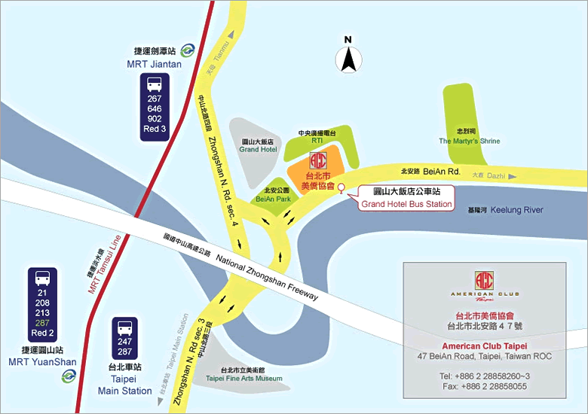
Registration Information

Date
[MON], July 16,2012

Venue
American Club Taipei
47 Bei-an Road, Taipei, Taiwan, ROC

Registration Fee
NT$3,000 per person.

Participants quota limit
80 persons.

Registration Procedures

You may register using three methods:

1. Online: Register on the Web of Actuarial Institute of the Republic of China (AIRC) (http://airc.org.tw/2011/viewnews.php?news_id=634) before July 12,2012.
2. Mail: Send registration form to airc.org@gmail.com before July 12,2012.
3. Fax: Fax registration form to 886-2-33652283 before July 12,2012.

Payment method
Payment will be collected in Check or Postal Giro (Check payable to:中華民國精算學會；Postal Giro Name：中華民國精算學會，Account No.：1511-1500) or on site pay.

Registration Form
Name | Company | Address | Phone | Fax | Email

